

Game title

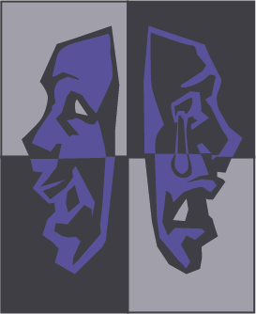

MASKED PRODUCTIONS

Kahali Griffin, Luke Herron, Sophia Harper, Mark Thomas Gyure, Jacob Stoedter





Table of Contents





Placeholder……………………………………………………3

Placeholder……………………………………………………4

Placeholder……………………………………………………6Placeholder……………………………………………………7

Placeholder…………………………………………………...11

Placeholder…………………………………………………...13

Placeholder…………………………………………………...19





?

Team Breakdown



Text text text text text text text text text text text text text text text text text text text text text text Text text text text text text text text text text text text text text text text text text text text

* Text
* Text
* Text



?

Placeholder

Section 1: Placeholder

Text text text text text text text text text text text text

text text text text text text text text text text

Text text text text text text text text text text text

text text text text text

Section 2: Placeholder

Text text text text text text text text text text text text

text text text text text text text text text text

Text text text text text text text text text text text

text text text text text

* Text text text text text text
* Text text
* Text text text text text text text text

?

?